|  |  |  |  |  |
| --- | --- | --- | --- | --- |
| The project name:Computer Engineering Role in COVID-19 Pandemic? The creator: Sawsan gamil soror Abdallah more info : group 3 sec 17 bn 366  Date: 6/7/2021  Application brief:-  I used visual studio coding based on some recommendation .. also because you can use multiple languages like HTML and CSS .  Github-link:-  [ece001/Help.html at master · sawsan-gamil/ece001 (github.com)](https://github.com/sawsan-gamil/ece001/blob/master/Help.html)  Github page (published website):-  https://sawsan-gamil.github.io/ece001/ |  |  |  |  |
|  |  |  |
|  | | |
|  |

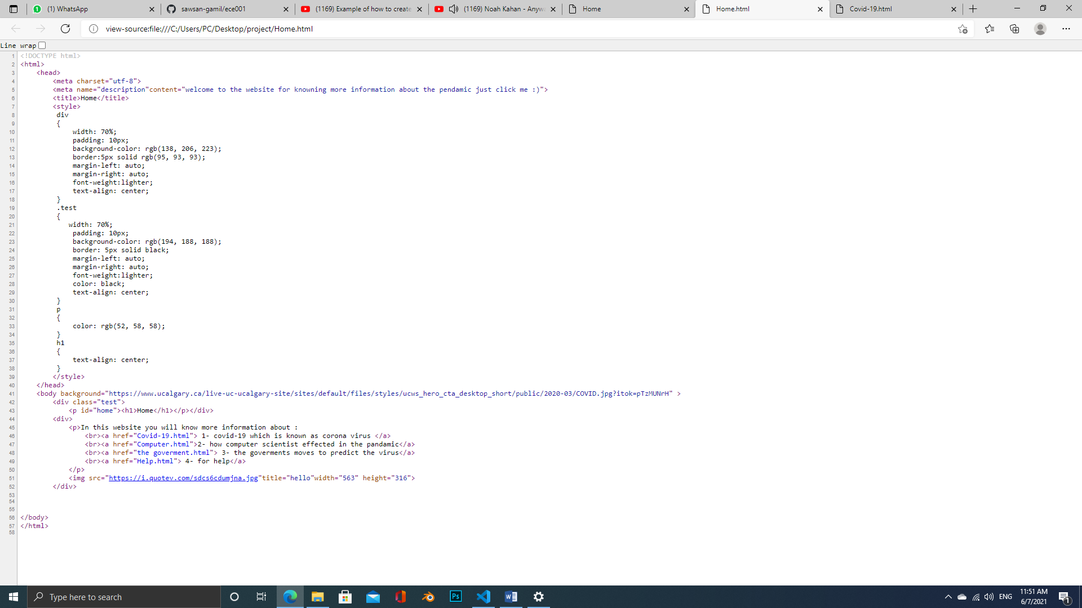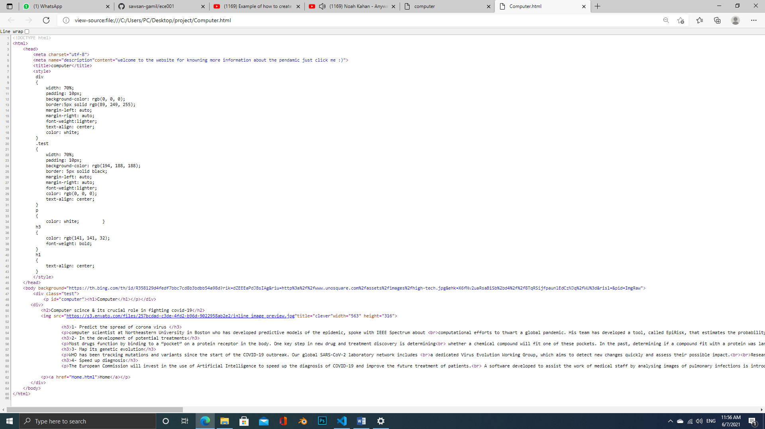

# **Source code : home page**

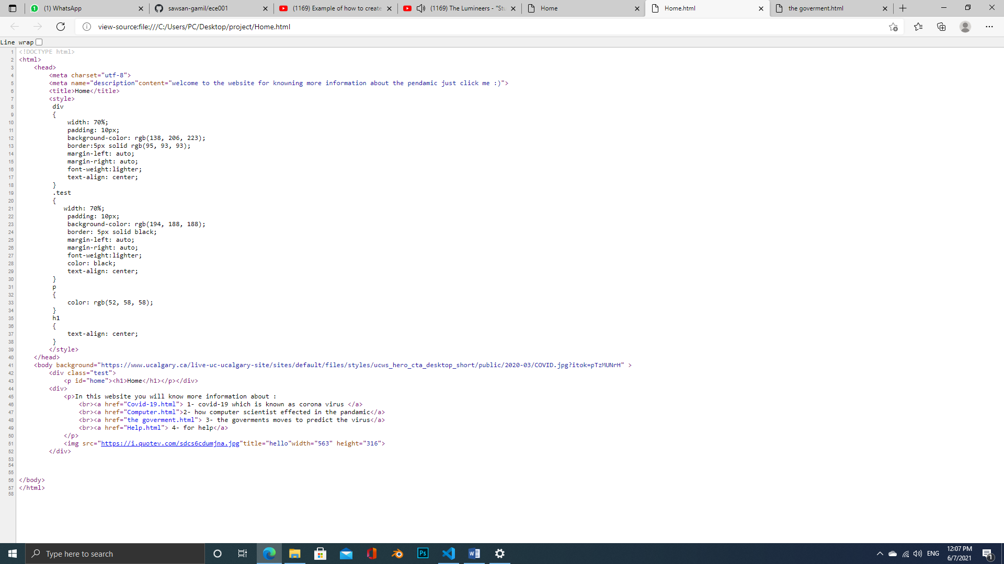

# **Source code : covid-19 page**

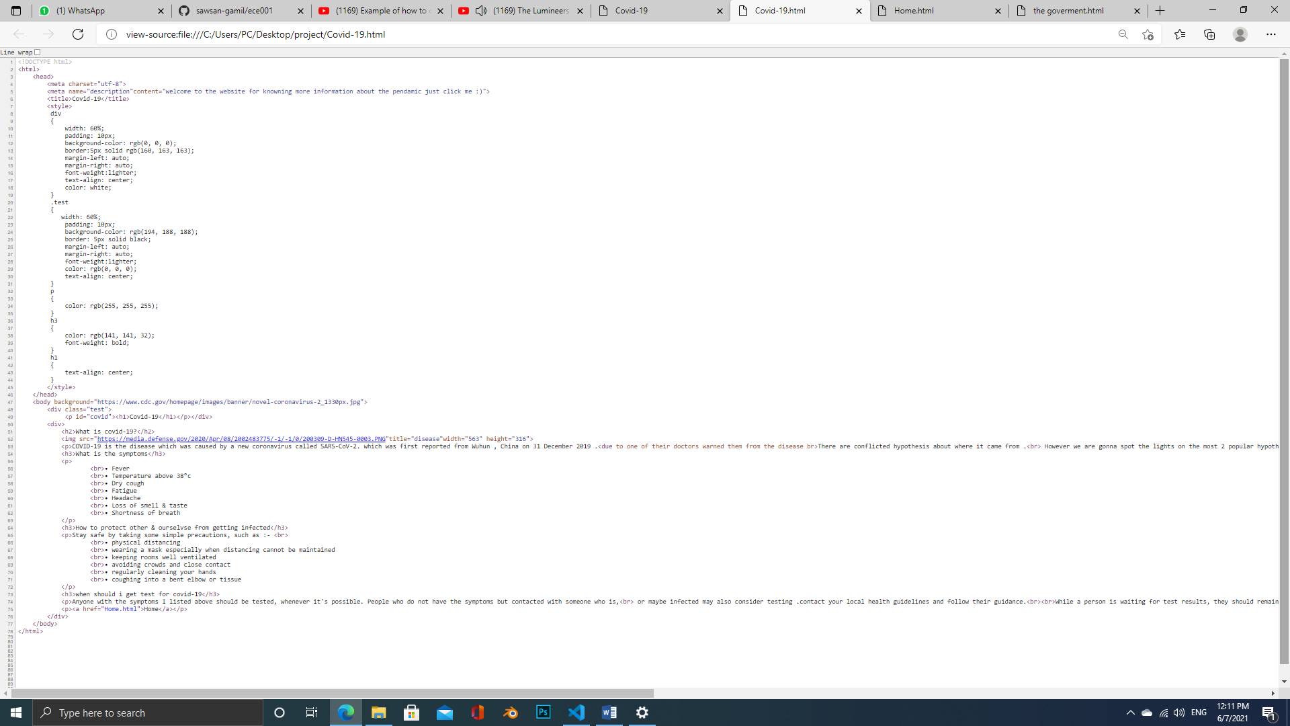

|  |  |  |  |  |  |
| --- | --- | --- | --- | --- | --- |
|  |  |  |  |  |  |
|  |  |  |
|  |  |  |
|  |  |

# **Source code : computer page**

Source code : government page

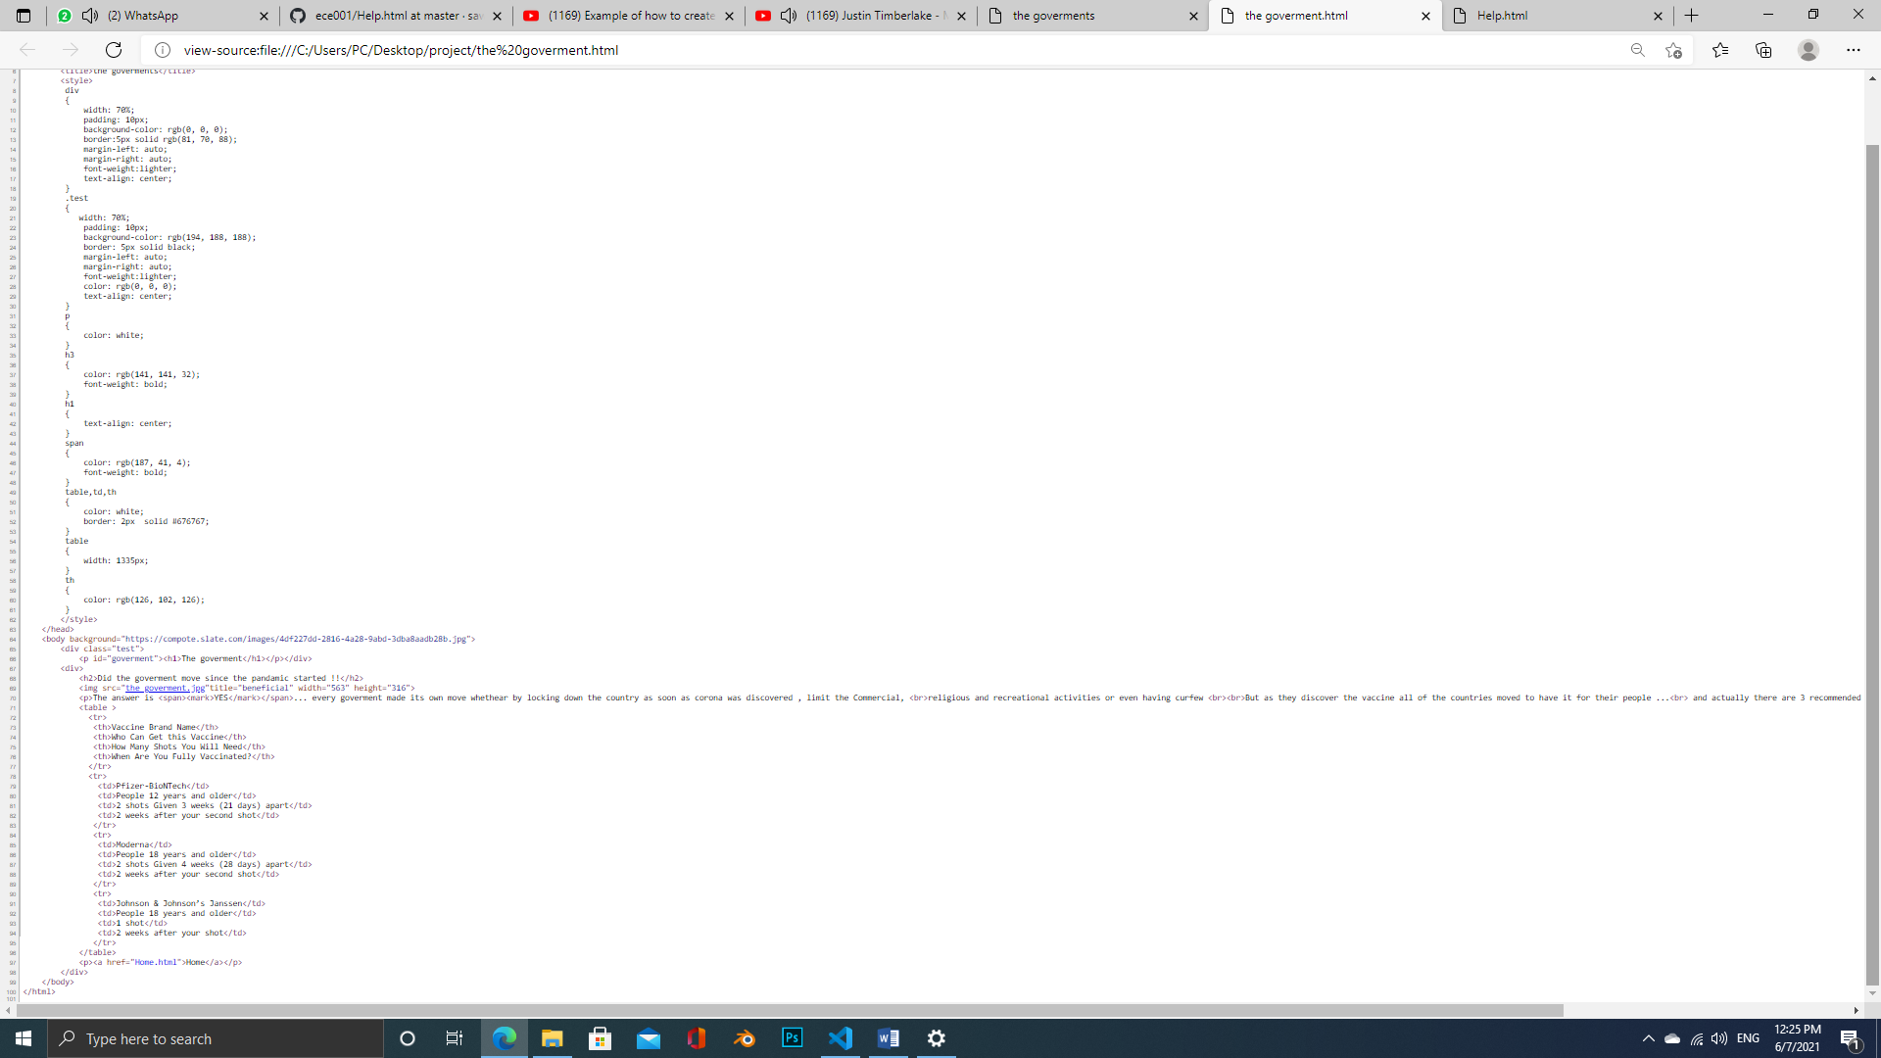

Source code : for help page

